Date access: 2020-03-10

<http://wjw.beijing.gov.cn/wjwh/ztzl/xxgzbd/gzbdyqtb/202001/t20200131_1622025.html>

From 24:00 on January 30 to 14:00 on 31st, 7 new cases of pneumonia infected with new coronavirus were added in this city

Date: 2020-01-31 Source: Beijing Municipal Commission of Health

        From 24 o'clock on January 30 to 14 o'clock on 31 January, 7 new cases of pneumonia infected with new coronavirus were added to the city, 6 of which had contact history in Hubei and other provinces, 5 were close contacts of confirmed cases, and 4 were People with contact history in Hubei and other provinces are close contacts of confirmed cases. All have been sent to designated medical institutions at the municipal and district levels for treatment.

As of 14:00 on January 31, a total of 139 confirmed cases were found in this city, including 1 death, 5 discharges, and 133 cases in isolated treatment at designated municipal and district hospitals. 3 cases in Dongcheng District, 16 cases in Xicheng District, 24 cases in Chaoyang District, 27 cases in Haidian District, 11 cases in Fengtai District, 2 cases in Shijingshan District, 1 case in Mentougou District, 12 cases in Tongzhou District, 2 cases in Shunyi District, 17 cases in Daxing District, There were 12 cases in Changping District, 1 case in Huairou District, and 11 cases came from overseas. No cases have been reported in Fangshan District, Pinggu District, Miyun District, and Yanqing District.

**1月30日24时至31日14时，本市新增7例新型冠状病毒感染的肺炎病例**

日期：2020-01-31 来源：北京市卫生健康委‍

        1月30日24时至31日14时，本市新增7例新型冠状病毒感染的肺炎病例，其中6例有湖北及其他省份接触史，5例为确诊病例的密切接触者，4例既有湖北及其他省份接触史又是确诊病例的密切接触者。均已送至市、区两级定点医疗机构进行救治。

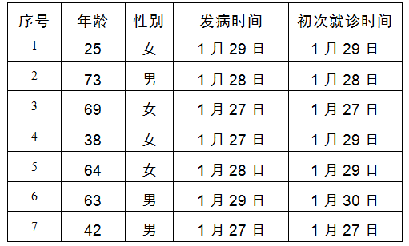

        截至1月31日14时，本市累计确诊病例139例，其中死亡1例，出院5例，133例在市、区两级定点医院进行隔离治疗。东城区3例、西城区16例、朝阳区24例、海淀区27例、丰台区11例、石景山区2例、门头沟区1例、通州区12例、顺义区2例、大兴区17例、昌平区12例、怀柔区1例，外地来京人员11例。房山区、平谷区、密云区、延庆区尚未有病例。